RPO And RTO

1. Min RTO for single AZ outage in case of multi-AZ database.

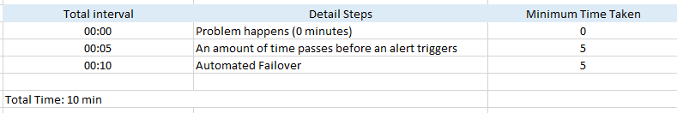

1. Min RTO for single region outage in case of multi-region database.

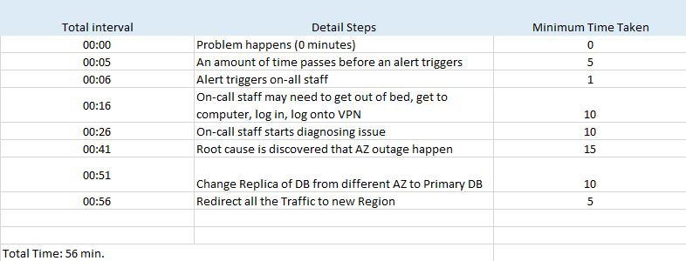

1. Min RPO for single AZ outage in case of multi-AZ database.

|  |  |
| --- | --- |
| Min RPO | Justification |
| 0 min | As all the data getting replicated there will be no loss of data. |

1. Min RPO for single region outage in case of multi-region database.

|  |  |
| --- | --- |
| Min RPO | Justification |
| 0 Min | As all the data getting replicated there will be no loss of data. |